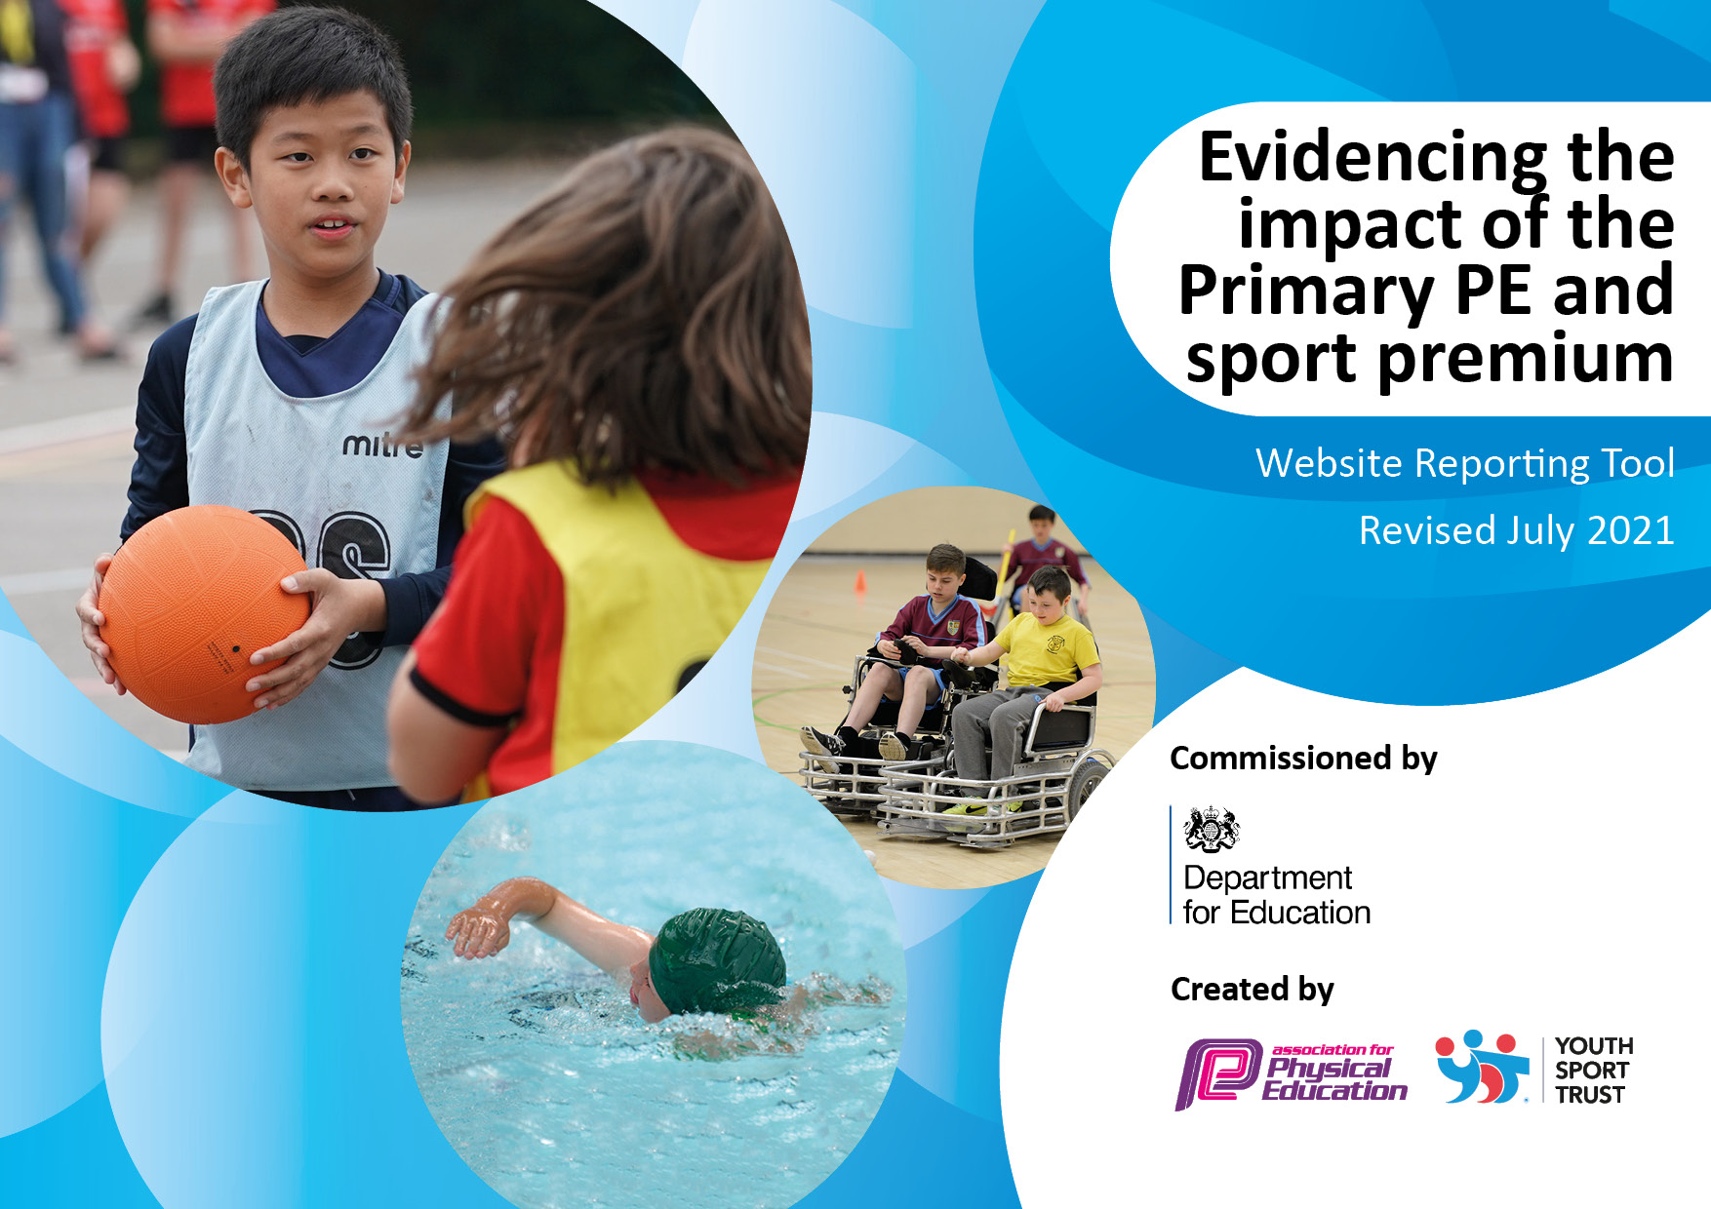

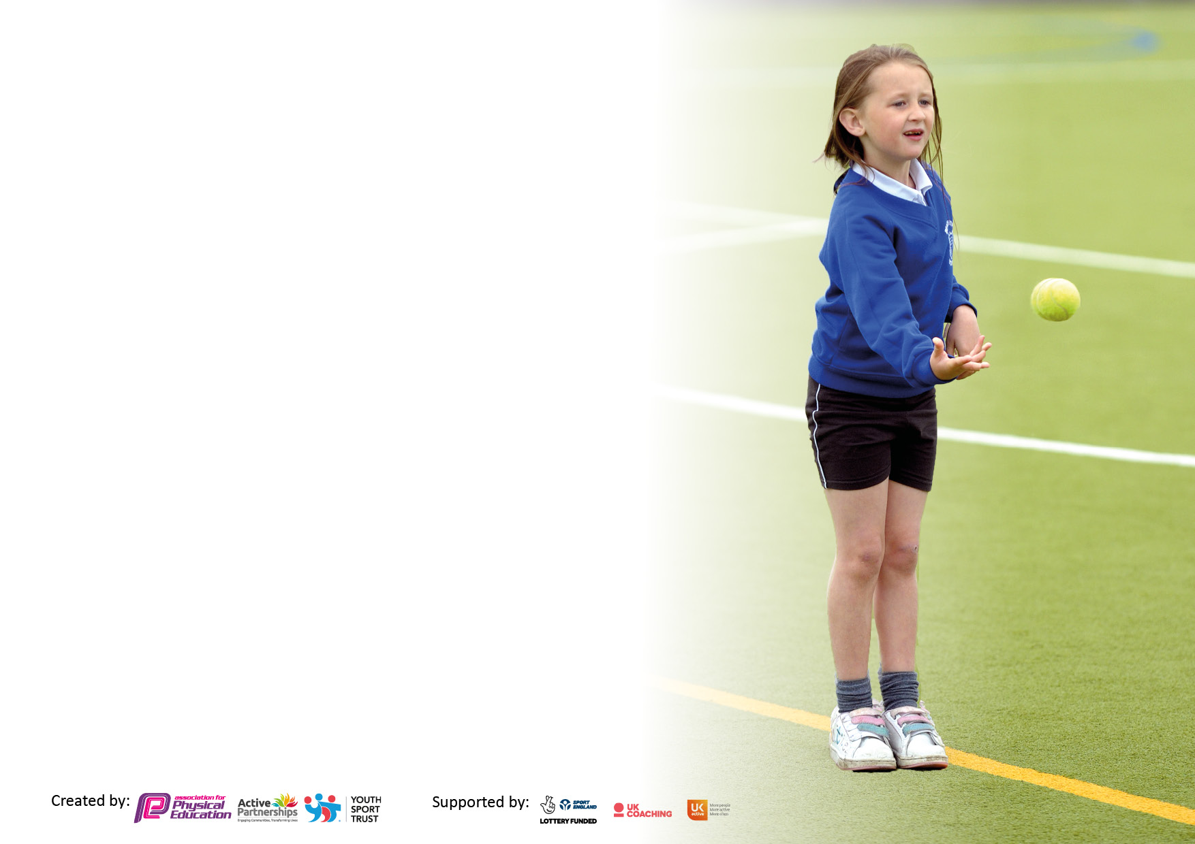

It is important that your grant is used effectively and based on school need. The Education Inspection Framework makes clear there will be a focus on ‘whether leaders and those responsible for governors all understand their respective roles and perform these in a way that enhances the effectiveness of the school’.

Under the Quality of Education Ofsted inspectors consider:
Intent - Curriculum design, coverage and appropriateness
Implementation - Curriculum delivery, Teaching (pedagogy) and Assessment
Impact - Attainment and progress

To assist schools with common transferable language this template has been developed to utilise the same three headings which should make your plans easily transferable between working documents.

Schools must use the funding to make additional and sustainable improvements to the quality of Physical Education, School Sport and Physical Activity (PESSPA) they offer. This means that you should use the Primary PE and sport premium to:

- Develop or add to the PESSPA activities that your school already offer
- Build capacity and capability within the school to ensure that improvements made now will benefit pupils joining the school in future years
- The Primary PE and sport premium should not be used to fund capital spend projects; the school’s budget should fund these.

Pleasevisitgov.ukfortherevisedDfEguidanceincludingthe5keyindicatorsacrosswhichschoolsshoulddemonstrate animprovement.Thisdocumentwillhelpyoutoreviewyourprovisionandtoreportyourspend.DfEencouragesschools to use this template as an effective way of meeting the reporting requirements of the Primary PE and sport premium.

We recommend you start by reflecting on the impact of current provision and reviewing the previous spend.

Schools are required to publish details of how they spend this funding, including any under-spend from the previous year.

We recommend regularly updating the table and publishing it on your website throughout the year. This evidences your ongoing self-evaluation of how you are using the funding to secure maximum, sustainable impact. Final copy must be posted on your website by the end of the academic year. To see an example of how to complete the table please click HERE.

Sports Premium Statement for the financial year ending on 31st March 2021

Details with regard to funding
Please complete the table below.

Total amount carried over on 31st March 2020 | £16,047.14
Total amount allocated for 2020/21 | £15,417.00
Total amount of Sports Premium available | £31,464.14
Expenditure during 2020 2021 financial year | £16,719.36
Amount carried over into 2021/22 | £14,744.78
Swimming Data: March 2021
Please report on your Swimming Data below.

Meeting national curriculum requirements for swimming and water safety.

N.B. Complete this section to your best ability. For example, you might have practised safe self-rescue techniques on dry land which you can then transfer to the pool when school swimming restarts.
Due to exceptional circumstances priority should be given to ensuring that pupils can perform safe self- rescue even if they do not fully meet the first two requirements of the NC programme of study
What percentage of your current Year 6 cohort swim competently, confidently and proficiently over a distance of at least 25 metres?
N.B. Even though your pupils may swim in another year please report on their attainment on leaving primary school at the end of the summer term 2020.
Please see note above
What percentage of your current Year 6 cohort use a range of strokes effectively [for example, front crawl, backstroke and breaststroke]?
Please see note above

What percentage of your current Year 6 cohort perform safe self-rescue in different water-based situations? | Not assessed
Schools can choose to use the Primary PE and sport premium to provide additional provision for swimming, but this must be for activity over and above the national curriculum requirements. Have you used it in this way? | No

Action Plan and Budget Tracking
Capture your intended annual spend against the 5 key indicators. Clarify the success criteria and evidence of impact that you intend to measure to evaluate for pupils today and for the future.

Academic Year: 2020/21 | Total fund allocated: | Date Updated:
Key indicator 1: The engagement of all pupils in regular physical activity – Chief Medical Officers guidelines recommend that primary school pupils undertake at least 30 minutes of physical activity a day in school |  |  |  | Percentage of total allocation:
 |  |  |  | %
Intent | Implementation |  | Impact
Your school focus should be clear what you want the pupils to know and be able to do and about  what they need to learn and to  consolidate through practice: | Make sure your actions to achieve are linked to your intentions: | Funding allocated: | Evidence of impact: what do pupils now know and what can they now do? What has changed? | Sustainability and suggested next steps:
The Sports Funding was used to purchase two new goals (MUGA) which are used daily in break times. The level of the game improves due to the ability of teams to aim and score goals. This makes the game more exciting and promotes engagement. Now that we have the goals, the PE teacher can keep a record of the outcomes of the games and run a mini, weekly competition. | We need to have some structure to our break times, so it is essential that PE equipment is available for the pupils to use. By purchasing good quality goals, we have facilitated teams games to take place. | £10,156.43 | More pupils are engaged in a physical activity and there are fewer negative incidents recorded. | Ensure teaching assistants are available to support these team games.  Staff can model and join in with the games  Teaching assistants promote participation  PE teacher to lead and ensure balls and other equipment is available.  PE teacher to organise team competitions at specific times in the year  PE teacher to investigate playing other schools at specific sport
Key indicator 2: The profile of PESSPA being raised across the school as a tool for whole school improvement |  |  |  | Percentage of total allocation:
 |  |  |  | %
Intent | Implementation |  | Impact
Your school focus should be clear what you want the pupils to know and be able to do and about  what they need to learn and to  consolidate through practice: | Make sure your actions to achieve are linked to your intentions: | Funding allocated | Evidence of impact: what do pupils now know and what can they now do? What has changed? | Sustainability and suggested next steps:
To train more staff in Level 3 Forest School  Members of staff will be undergoing Level 3 Forest school training and deliver lessons to Primary and Secondary education. This will promote the holistic development of pupils, fostering resilient, confident and independent learners | Our aim at Caldecott School is to provide 2 weekly sessions of Forest School to pupils in Primary and 1 session per week to pupils in Key Stage 3 (Secondary). | £880 x 2 = £1,760 | Staff have delivered child-initiated and structured forest school learning to pupils in primary and secondary education. Forest school sessions now taught 4 hours in primary and 2 hours in secondary that has helped develop confidence and social skills within our young people. It has provided pupils with the freedom, time and space to learn and demonstrate independence. Children have also gained awareness of the consequences of their actions on peers through team activities such as tool sharing and participating in play. | Forest School remains an integral part of our curriculum offer. It meets the needs of our pupils on a number of different levels.  - Promotes social communication  - Promotes speaking and listening skills as pupils work collaboratively  - Promotes independence and problem-solving skills  - Promotes physical activity  - Promotes emotional well-being  More Level 3 trained staff in both Primary and Secondary.
Astro turf laid in the courtyard in the Secondary School.  This enables pupils to play safety in this area. | The Astro turf was laid by a professional company ensuring it is safe and will last. | £3,951.60 | This area can also promote the well-being of the pupils as they use this area to sit / lie down when they need to take time out of the classroom. This is a commonly used strategy for many of our pupils and is written on their Individual Behaviour Support Plan | This area can be developed and used to promote well-being.  Pupils use this area at break times for social interaction.  Pupils continue to use this area to self-regulate.
A trampoline was purchased to use in Secondary.  We know our pupils like to bounce as this helps them to calm. It also supports some of our pupils who need to keep moving.  Trampolining is also an excellent sporting activity to promote fitness. | Our aim is to have 1 trampoline in Primary and 2 trampolines in Secondary | £851.33 | When the trampoline was first brought onto the site it was placed in the Key Stage 3 area. There were arguments about whose turn it was. These obstacles were overcome with a strict use of the timer. There were still a couple of pupils who found it difficulty coming off the trampoline.  We placed a trampoline at the back of the school but there was an injury shortly afterwards, so the trampoline was removed from the site. | Funding needs to be allocated to make a level base for the 2 trampolines so they can be secured safety.  We need both trampolines on site and pupils need to learn to use them safely.

Key indicator 3: Increased confidence, knowledge and skills of all staff in teaching PE and sport |  |  |  | Percentage of total allocation:
 |  |  |  | %
Intent | Implementation |  | Impact
Your school focus should be clear | Make sure your actions to | Funding | Evidence of impact: what do | Sustainability and suggested
what you want the pupils to know | achieve are linked to your | allocated: | pupils now know and what | next steps:
and be able to do and about | intentions: |  | can they now do? What has
what they need to learn and to |  |  | changed?
consolidate through practice:
Key indicator 4: Broader experience of a range of sports and activities offered to all pupils |  |  |  | Percentage of total allocation:
Intent | Implementation |  | Impact
Your school focus should be clear | Make sure your actions to | Funding | Evidence of impact: what do | Sustainability and suggested
what you want the pupils to know | achieve are linked to your | allocated: | pupils now know and what | next steps:
and be able to do and about | intentions: |  | can they now do? What has
what they need to learn and to |  |  | changed?
consolidate through practice:

Additional achievements:

Key indicator 5: Increased participation in competitive sport |  |  |  | Percentage of total allocation:
 |  |  |  | %
Intent | Implementation |  | Impact
Your school focus should be clear | Make sure your actions to | Funding | Evidence of impact: what do | Sustainability and suggested
what you want the pupils to know | achieve are linked to your | allocated: | pupils now know and what | next steps:
and be able to do and about | intentions: |  | can they now do? What has
what they need to learn and to |  |  | changed?:
consolidate through practice:

Signed off by
Head Teacher: | Karen Norman
Date: | 29th April 2022
Subject Leader: | Keanu Barnett
Date: | 29th April 2022
Governor:
Date:

